Written Evidence Submission for YWL Employee Group

Aim: To investigate what measures are being taken to increase employment opportunities for women from black and minority ethnic backgrounds aged 16-30.

Section 1 - Method of Engagement

This year’s Young Women Lead cohort chose to investigate the transition from education to employment for young women from BAME* backgrounds aged between 16-30.

*Black, Asian and Minority Ethnic.

1.1 BAME employees aged 16-30 Survey

The Employment group agreed that it was necessary to launch two online surveys for employers and employees. The employee survey was hosted on Google Forms for eight weeks with an aim to gather insight into BAME women’s lived experiences of employment in Scotland. This survey was promoted through various communication channels including e-bulletins, third sector organisations, influencers, Facebook, Instagram, LinkedIn and Twitter. It was also disseminated through Committee members’ personal networks and relevant Scottish Government stakeholder groups.

The survey questions were agreed as a group to focus on the following themes:

- Organisational representation of women in the BAME community;
- Organisational policy, culture and strategy in creating an inclusive environment;
- Equality, Diversity and Inclusion plans and discrimination;
- Leadership, support and proactive sourcing measures.

Section 2 - Results

2.1 Survey of Young BAME Women employees

Number of Completed Employment Surveys | 102

1.
Figure 2.1
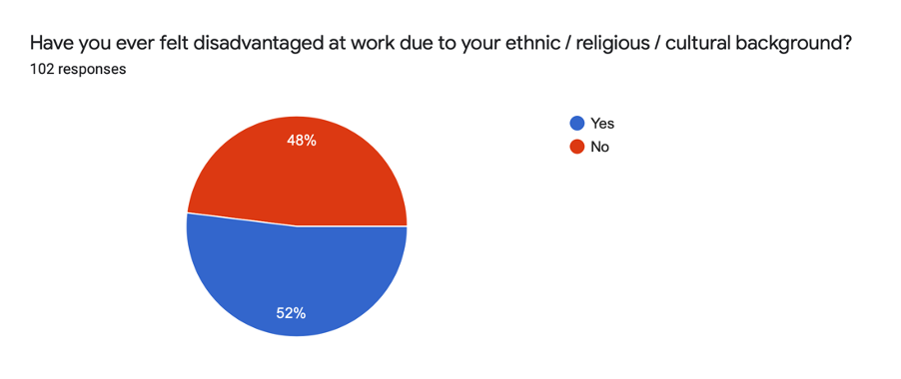

Summary

Each individual, irrespective of their background and ethnicity should be able to reach and fulfil their potential at work. However, the data demonstrates the answers were split rather evenly. Notably, more than half of the respondents (52%) have felt disadvantaged at work due to their ethnic / religious / cultural background. Although a narrow majority, it is evident from these statistics that there still exist barriers to equal opportunities within the workplace.

- Figure 2.2

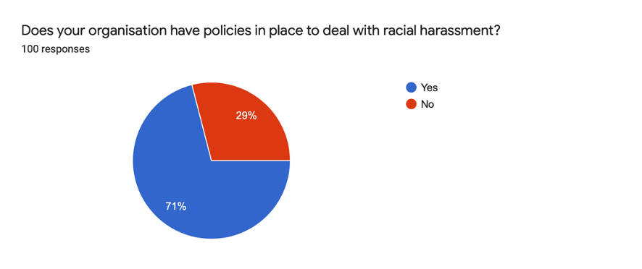
Summary

The majority of respondents stated their organisation had policies in place to deal with racial harassment. Those who said yes stated that these policies included reporting to the line manager, ‘Zero tolerance’ policy and supportive HR departments, diversity and inclusion committees, training for new employees, disciplinary procedures and a referral system to the local authority.

However, amongst the 21% who said there were no policies in place, comments included being “not sure” or “can’t remember.” The responses suggested that more work ought to be done by employers to not only create policies to deal with racial harassment but to ensure employees are aware of policies and procedures.

- Figure 2.3
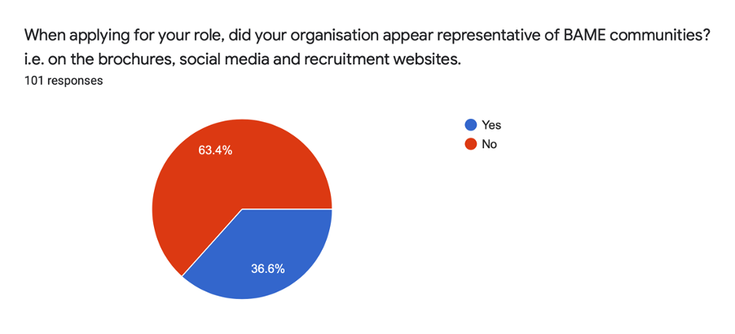
Summary

More than two-thirds of respondents found that their role did not appear representative of BAME communities.

- Figure 2.4
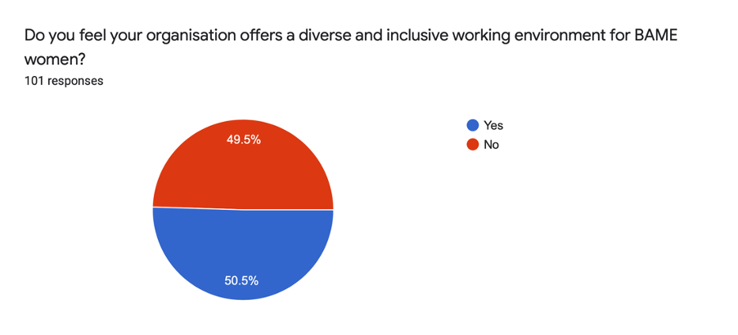
Summary

A mixed response was evident. Half of the respondents found that their organisation offered a diverse and inclusive environment.When asked why they felt this way, the respondents who said yes had the following comments:
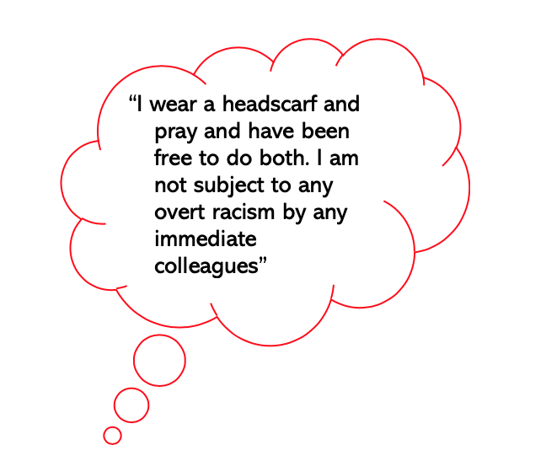
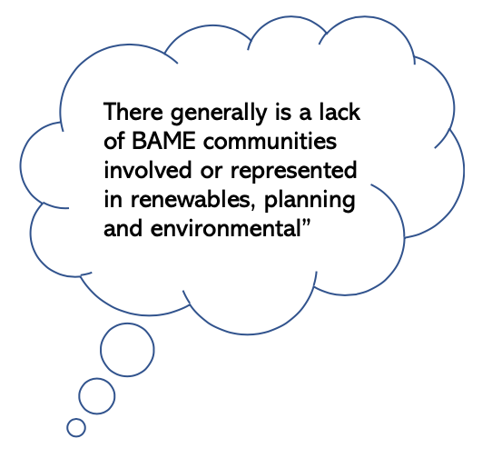
*
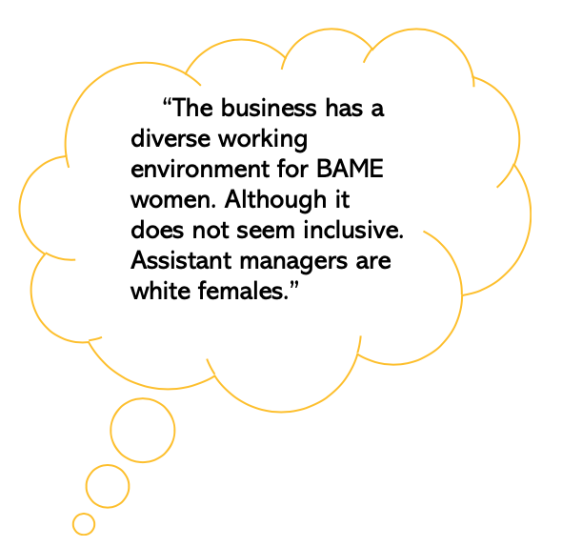
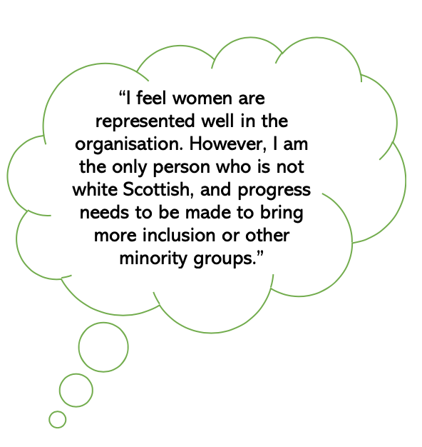
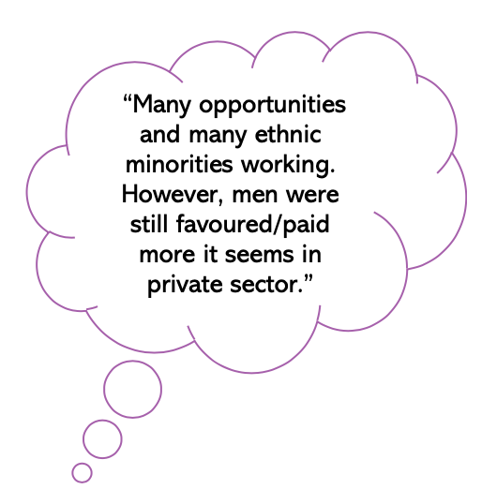

*The above are direct quotations from the survey conducted provided for the purpose of elaborating on statistics.

When asked why, the respondents who selected no stated:

*
- “Many people asked were the only,
or one of the only, BAME women (or person)
in their company e.g. It has never been a focus.
As an employee for over four years, I have only
come across two other people who are black/African.”

- “as a practicing Muslim I have struggled to find the space to pray during my time at work and I feel like I can’t voice my need”

- “I was bullied at work where there was a big racial
element. The management turned a blind eye”

- “the reality is that there are barely 1 or 2 people of colour in a team of 40. [And] often representation can be an afterthought, or they feel uncomfortable addressing this issue more strongly because they feel they're not the right people to do it as they are all white women. what the problem is, and they haven't identified is that they need more women of colour in the organisation so that it doesn't feel like they're speaking FOR them.”

- “in day to day communications there is unconscious
bias. It would be good if there was mandatory training
on unconscious bias because this plays out in recruitment.
And finally, I feel that they always make the same excuses as
to why they're not reaching out to a more diverse pool of
candidates: lack of resources (time and money), but this is
just an excuse and a lack of proper planning and intention.”

*The above are direct quotations from the surveys provided for the purpose of elaborating on statistics.

Thus, despite prima facie appearing to be an equal split, upon closer examination of the data the majority of respondents expressed concerns suggesting that their working environments were not actually as diverse and inclusive as they ought to be. This is an important observation, given that respondents felt there was a lack of representation within the workplace. A diverse and inclusive working environment is essential for employees to feel accepted and valued.

- Figure 2.5

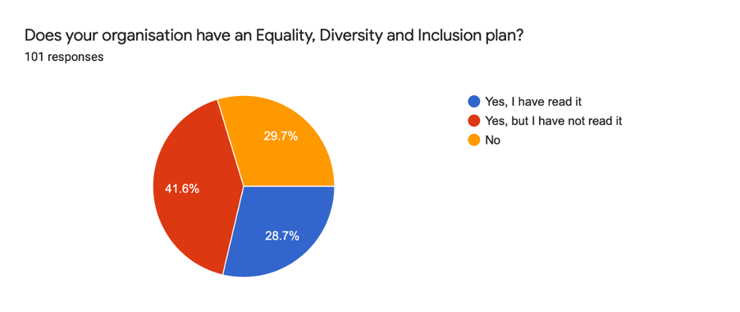

Summary

As the vast majority of respondents having not read any plan in place, it is unequivocal that greater measures should be taken to create an Equality, Diversity and Inclusion plan and to bring this to the attention of employees to ensure effective implementation.

- Figure 2.6
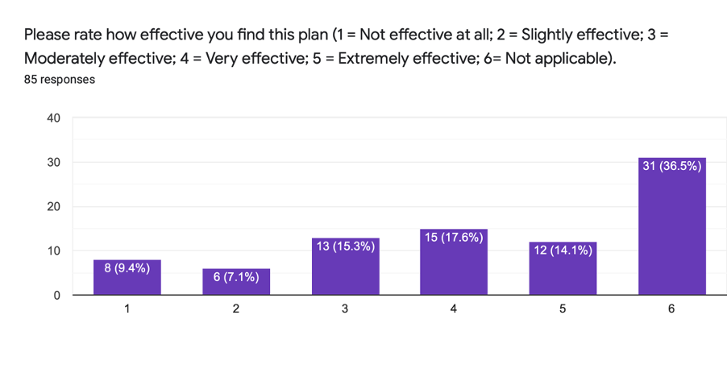

Summary

When asked about the effectiveness of the plan, the responses were spread across the board. The majority felt answering about the effectiveness of a plan was not applicable- due to there being no such plan in place. However, those who did have a plan in place within their organisations had no significant response- with the majority voting for moderately effective or above. Thus, ostensibly organisational plans appear to have had minimal efficacy and more work ought to be done to ensure an effective Equality, Diversity and Inclusion plan.

- Figure 2.7
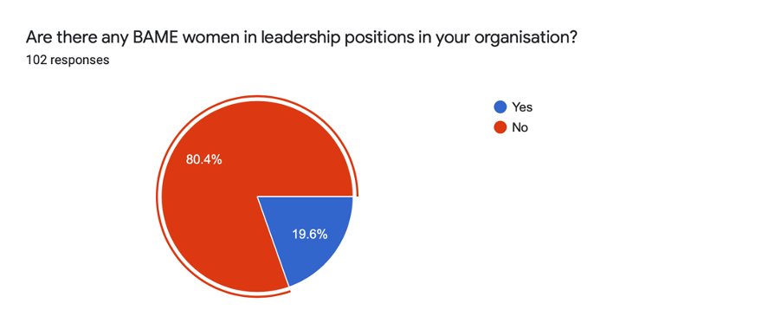

Summary:

The small percentage of respondents who voted yes were asked about the impact of having BAME women in leadership positions within their organisation. Their responses varied from it being ‘extremely heartening and inspirational’ and ‘shows progression is possible’ to highlighting ‘Inclusivity, people are not judged based on their ethnic origin but rather their abilities and experience.’*

The responses highlighted a common thread of ‘wider understanding,’ where a BAME woman in a leadership position translated to being ‘able to easily express our needs’ and organisations being able to ‘better understand the culture and background the staff and clients are coming from.’*

*The above are direct quotations from the surveys provided for the purpose of elaborating on statistics.

- How does your organisation support young BAME women and their career progression?

Summary:

The majority of respondents answered ‘unsure / don’t know / not applicable.’ A shared sentiment amongst respondents was the desire for more support. In fact, respondents highlighted that they ‘did not feel supported.’ It is evident from the responses that there is ‘there is nothing specific for BAME women’ and their career progression - with only two respondents from the entire sample actually noting they are being supported as BAME women, distinct from white co-workers.

- Figure 2.8
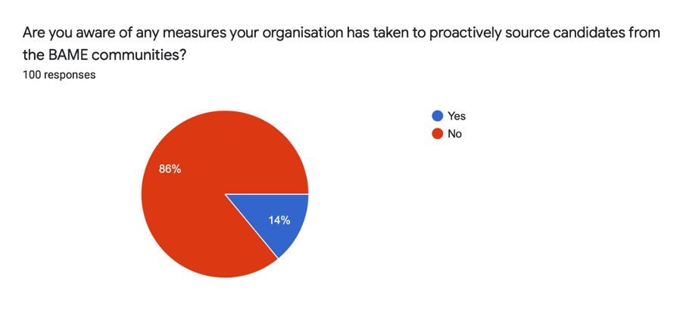
Summary:

The 14% of respondents who knew of measures their organisation had taken to proactively source candidates from BAME communities were asked what these measures were.

Examples of these can be seen below. However, three of these responses highlighted a lack of action. Interestingly, reference was made to the ‘recent black lives matter movement’ with organisations vowing to increase representation without any such implementation as of date, leaving the respondents ‘with little to no support from the people in charge.’

The majority percentage of respondents who were unaware of measures being taken, were asked to suggest actions their organisation could take to proactively source candidates from the BAME communities. Many were unsure, but the majority of responses here highlighted the need for organisations to connect and collaborate with BAME organisations to help create a BAME narrative to avoid bias in the sourcing process. Interestingly, overlap with the education group’s findings was evident; respondents highlighted the need for “mentor and development schemes” for “young BAME women in school,” with a “focus on people of colour.” The position of a ‘specific Equalities and Diversity officer’ was also mentioned.

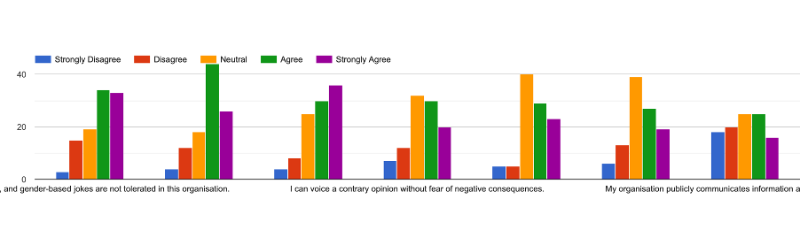
- Figure 2.9
Q1. Gender based jokes are not tolerated within this organisation

- The most common responses were agree and strongly agree.

Q2. My organisation vouches to take strong action against discrimination

- The most common responses were agree.

Q3. I am comfortable talking about my background and cultural experiences with my colleagues

- The most common responses were neutral, suggesting more could be done for employees to feel comfortable

Q4. I can voice a contrary opinion without fear of negative consequences

- The most common responses were neutral, suggesting more could be done to allow employees to voice their opinions without fear.

Q5. My manager handles diversity matters appropriately when approached.

- The most common responses were neutral, suggesting more could be done by managers.

Q6. My manager demonstrates a commitment to diversity and inclusion of BAME women.

- The most common responses were neutral, suggesting more could be done by managers.

Q7. My organisation publicly communicates information about its diversity goals.

- The majority of respondents selected ‘disagree’ and ‘strongly disagree,’ underlining the need for organisations to take more action.

Summary:

The answers were rated on a scale, with a broad range of answers recorded. However, the common theme underlined was the need for organisations to take more action.

- Finally, at the end of the survey space was also left for additional comments.

Thematically, the additional comments focussed on:

- Lack of young BAME women representation within the workplace in comparison to their male counterparts, feeding in to industry specific stereotypes:-

Direct quotations:

- “ [However] we only have one male member of staff from the BAME community who works in the kitchen. It is important to know that it is a small independent business however I do not think they do enough to recruit candidates from the BAME community.”

- “I feel like there's not many BAME women in hospitality/travel. It would be inspiring to see that, especially in Scotland. It would encourage more women to work in these industries, which are sometimes looked down on for whatever reason.”

- “In quite a few industries, I don't see many BAME women, especially in Glasgow. Males, however, are significantly more. Young girls would have role models like them to look up to.”

- “Planning, environmental and renewables is vastly underrepresented. It’s notable in university degrees, various companies, at seminars, events and even award events.”

- A fundamental need for a BAME narrative in the workplace, to ensure equality and fair representation. Provision of equality includes focus on the intersectional lens :-

Direct quotations:

- “it would be nice for everyone to be treated with the dignity and respect they deserve, no matter their background or appearance”

- “I am co-lead to the new BAME Staff network. Prior to me starting my role, there has never been a BAME staff network. Although I instigated dialogue for the network, I was pursued to commit. There is no diversity and inclusion plan, but there is an inclusion statement which is vague in terms of racial representation. This has no action plans but statements of intent.”

- “The university has started a BAME working group (working to put a new action plan to support the BAME community) resulting from the outcry from students and staff resulting directly from the BLM Movement gaining momentum in mainstream society. The organisation is big on representing women's equality and LGBT rights, but this is not looked at in an intersectional lens. This is deeply problematic.”

- “ In the previous local council (last year) I had to deal with racial harassment/jokes from a colleague & it was not dealt with to the manner that it should have. It was very much “brushed under a rug”. Whether this was to do with my experience at the time, but it was a very uncomfortable experience, more due to lack of management and how it was dealt with.”

- “We have more work to do to communicate our work externally, especially in the current context of performative ally ships being rampant across the creative industries. We are taking our time sharing our commitments without being tokenistic and without putting myself as a BAME woman director in harm’s way in terms of extreme emotional labour, but we will be doing more to communicate this soon.”

- Heightened concerns over the impact of COVID-19 on representation within the workplace:-

Direct quotations:

- I worry about how the effects of COVID-19 may have the largest impact on women of colour in terms of career development and progression. Organisations that didn't care much about diversity before, like mine, certainly care less now as they go into survival mode. It's disheartening that their approach to survival involves going back to top-heavy and predominantly white structures.

Fundamentally, as emphasised by the respondents, ‘the system needs to change!”

Section 3- Online Focus Group

Young Women Lead 2019-2020
Online Focus Group
6 August 2020

3.1 Executive Summary

To maximise engagement opportunities, within the timeframe, the Young Women Lead 19/20 cohort adopted a variety of engagement methods. This included further engagement work with survey respondents with the purpose of building on previous engagement initiatives and to engage in depth with young BAME women who have experience of employment in Scotland.

In order to comply with Government guidelines during the COVID-19 pandemic and ensure all participants were able to attend, the cohort invited interested survey respondents to a digital focus group which aimed to support open, respectful discussion of experiences and ideas.

3.2 Aims

The aim of the focus group meeting was to gather lived experiences of employment for young BAME women in Scotland.

The focus group was attended by 9 young women from diverse ethnic backgrounds (including African, Asian and European) based across Scotland. The focus group represented young BAME women across the public, private and third sectors.

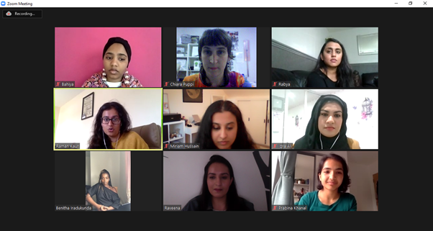
3.3 Focus group questions

1) What challenges do you feel young BAME women face in accessing the labour market?
2) What career development support would you like to have in a workplace to meet your needs as a young BAME woman?
3) What would make a workplace a diverse and inclusive space?

3.4 Discussion

The focus group focused on the process of finding opportunities to apply to, the recruitment process and career development following successful appointments. The majority of participants reported their experiences in employment as moderate or negative.

The overarching themes that emerged were:

- Young BAME women do not feel they can present their true self during the recruitment process and as employees in the workplace
- Young BAME women feel that employers have presumptions around capability based on gender and ethnicity
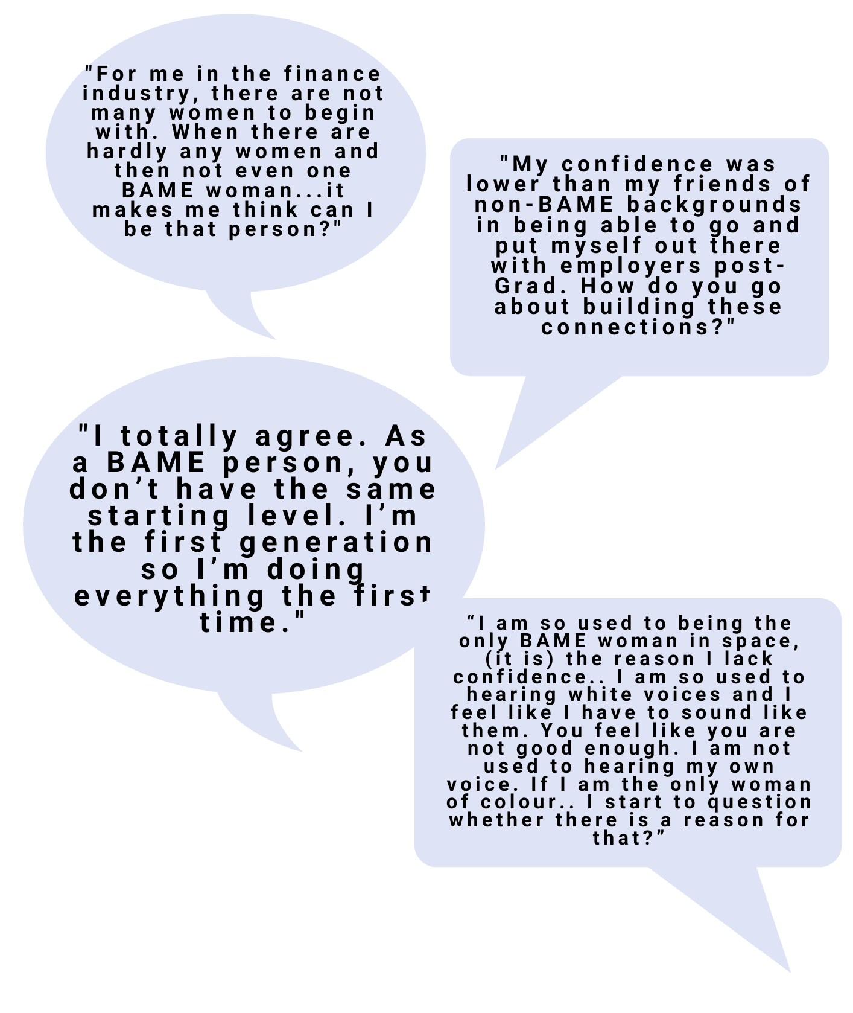
- Young BAME women agree there is great value in mentorship and role models in increasing self-confidence.

The majority of women who participated in the focus group shared that the lack of networks and female role models to look up to either in the home environment or chosen industry has affected their confidence and limited their ambitions. The group suggested that BAME representation across sectors is limited and can impact self-confidence for one’s progression opportunities.

The group suggested that having a diverse workplace and an inclusive environment can have a positive impact on employee’s confidence.

Another aim of this focus group was to capture the end-to-end recruitment process for BAME women including the stage of looking and applying for opportunities. For all the women who contributed, the following issues came to forefront multiple times:

- Name prejudice affecting how your application is perceived;
- Unconscious bias and preconceived notions about capability based on physical appearance or ethnic name;
- Foreign qualifications or experience not being recognised as equivalent;
- Bilinguality (English as a second language) not being seen as an indicator of strength in the labour market.

All of the women with whom we spoke indicated that their migration status either as first generation or second generation children put them at a disadvantage in accessing the labour market. This was shared as a lack of social capital, lack of role models and lack of foreign qualification equivalence.

By participating in this focus group, women shared some very personal information. For many, particularly during the last question about career development, this proved to be a very reflective experience. This was mostly evident when they shared what would support their professional development and ability to bring their whole selves to work. Participants spoke about the value of mentorship, peer-mentorship and networking in building confidence and navigating career progression paths and professional development and yearly reviews. In particular, many participants spoke of the importance of a welcoming workforce and workplace through BAME staff networks, designated spaces for praying and acknowledgment of diverse festivals and holidays.

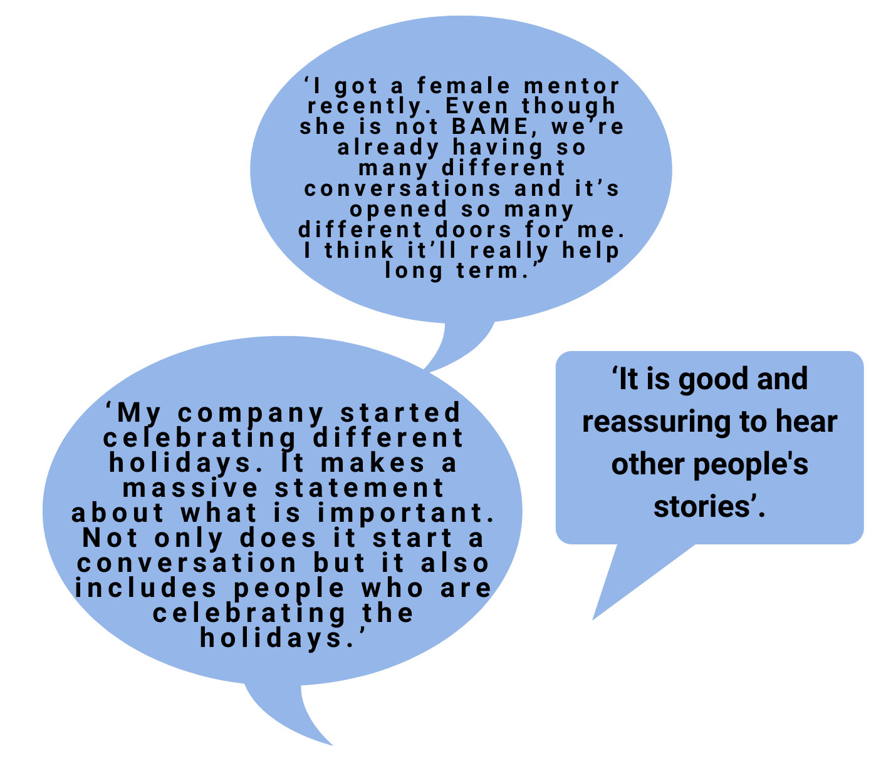

Training is commonly discussed as a diversity initiative. This was also discussed by the participants during the focus group but it was stated that this is ‘not just about training’ but also related to name blind recruitment, reporting of the gender pay gap and the importance of evaluating outcomes by disaggregated data across even BAME communities.

The group also noted that a diverse and inclusive workforce and workplace should not just be about training but incorporated into the recruitment process itself. It was agreed that employers should base recruitment on values too and that ‘diversity’ training during employee induction should act as a reinforcement in demonstrating employer values.

Section 4 - Conclusion

Through both the employee survey and focus group, valuable lived experience insight from the perspectives of young BAME women in employment was gathered. There was a striking degree of coherence amongst the sample whereby the majority of the participants expressed critique with current practices in place, with many citing that a plan is often not put into action or effectively evaluated although it remains visible externally. While there is room for further research regarding the effectiveness of Equality, Diversity and Inclusion plans and policies in the workplace, the employer survey results underline that employers are generally satisfied with their current BAME policies and plans, however, the results from the employee survey provide a contrasting narrative. The question remains as to which policies and best practices can be put into place to remedy the current organisational culture and practices which more than half of all employee survey respondents felt disadvantaged them within the workplace.
There was also agreement amongst the sample size that targeted mentorship opportunities and greater senior BAME representation within the workplace for young BAME women would increase confidence and reduce the effects of systemic disadvantage in achieving career and financial growth. It was also cited that employers should be working directly with BAME communities to increase awareness of job and networking opportunities in place of a lack of social capital and review their recruitment and organisational culture practices to be reflective of an international and culturally diverse Scottish society. It was suggested that there are a number of third sector organisations that could provide employers with this access into different Scottish BAME communities to increase their representation as well as awareness-raising training offers to create more inclusive workplaces.
The qualitative approach taken offers unique lived experiences and viewpoints to offer in how improvements can be made for young BAME women in employment in Scotland. While the focus group sample size in particular would have benefited from an equal number of participants across sectors, the raw data samples in the employee survey demonstrate that recruitment processes and HR practices have not been effective from the perspectives of young BAME women who are already in the labour market and across sectors; given this does not include young BAME women excluded from the labour market, this should be considered sufficient data to inform change in debate and discussion, if not best practice and policy design and implementation.

